**EXP NO 1:** Create a simple cloud software application for Flight Reservation System using any Cloud Service Provider to demonstrate SaaS include the necessary fields such as one way, round trip, From, to, Departure, Departure, Travelers & Class, Fare Type, International and Domestic Flights etc.

**DATE:21/02/2024**

**AIM:**

To Create a simple cloud software application for Flight Reservation System using any Cloud Service Provider to demonstrate SaaS include the necessary fields such as one way, round trip, From, to, Departure, Departure, Travelers & Class, Fare Type, International and Domestic Flights etc.

**PROCEDURE:**

**STEP 1: open the zoho.com and create a new application and name the application.**

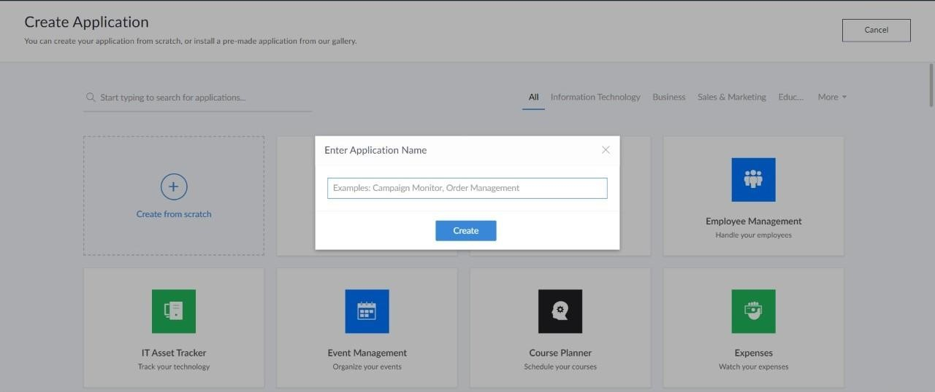

**STEP 2:now select the form.**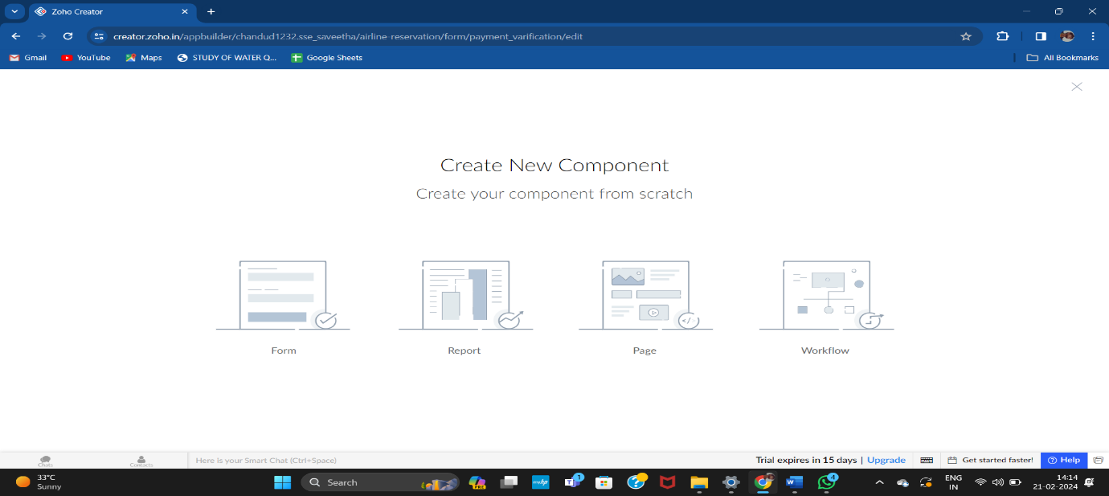

**STEP 3: NOW choose the option select from scratch because we are creating using our own idea.**

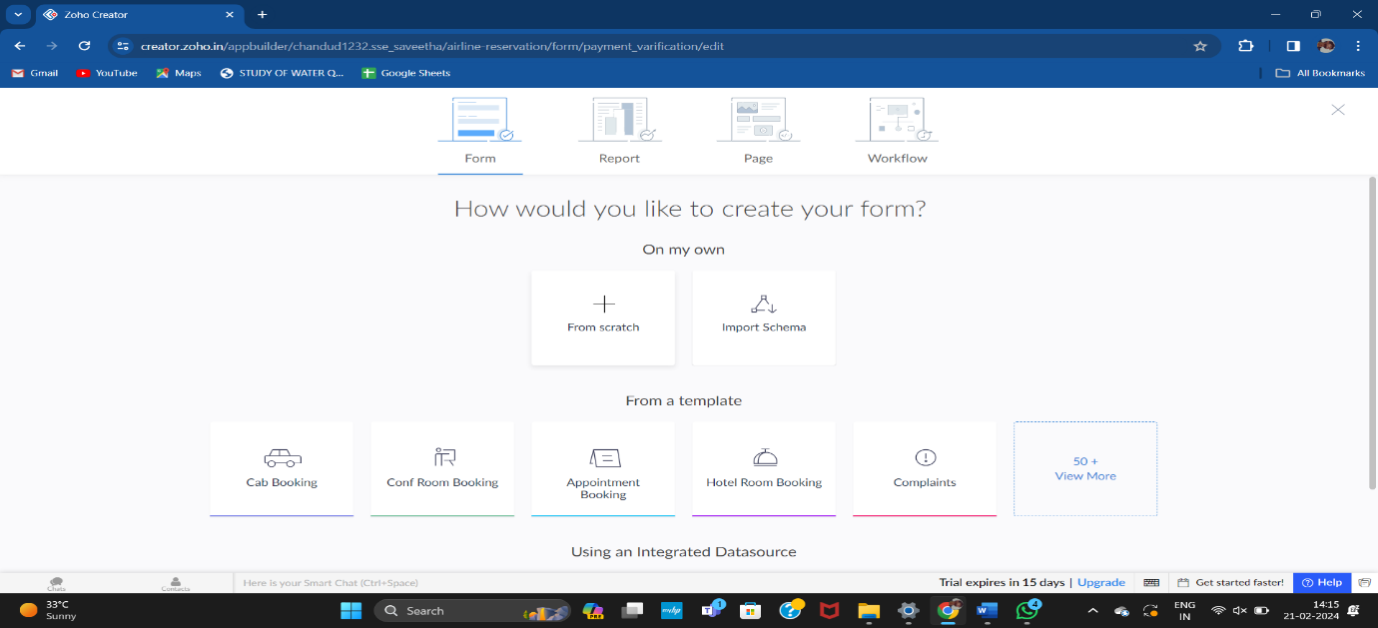

**STEP 4:now enter the form name like “log in”**

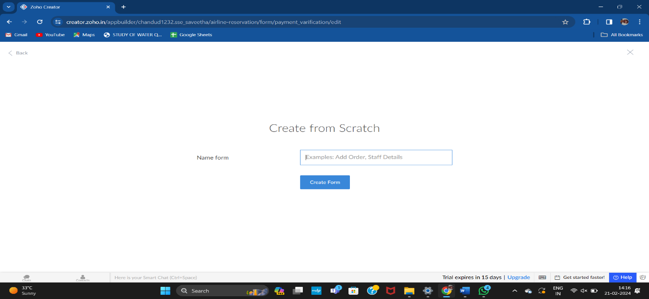

**STEP 5: NOW ADD THE REQUIRED PROPERTIES like “name , email, password , phone, agree statement etc.**

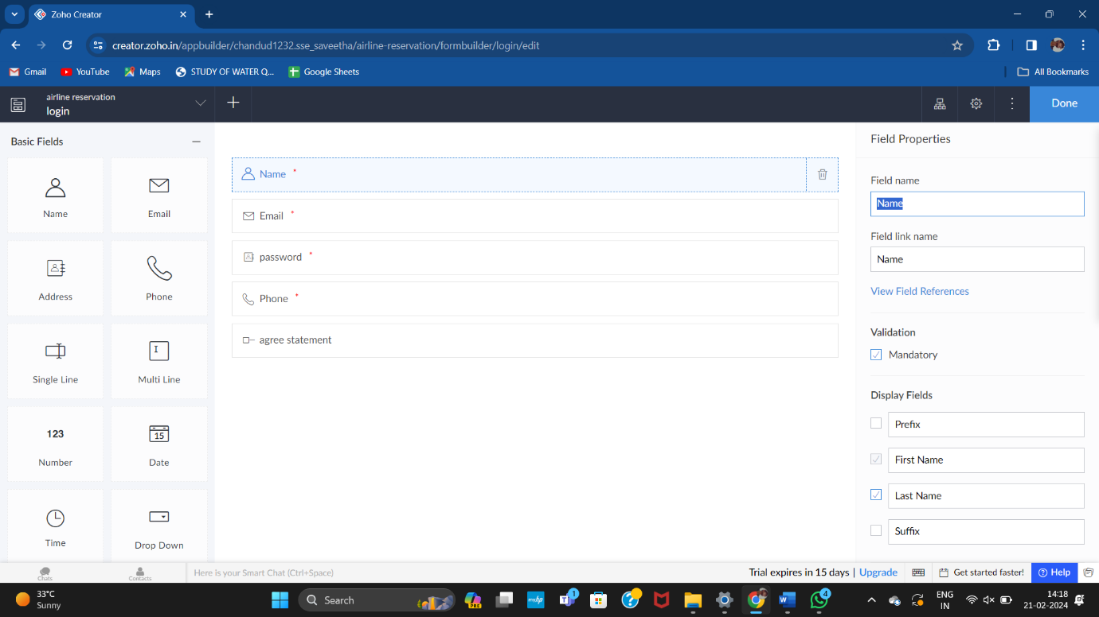

**STEP 6: NOW SELECT THE NEW FORM FOR CREATING ANOTHER FORM LIKE “VERIFICATION”.**

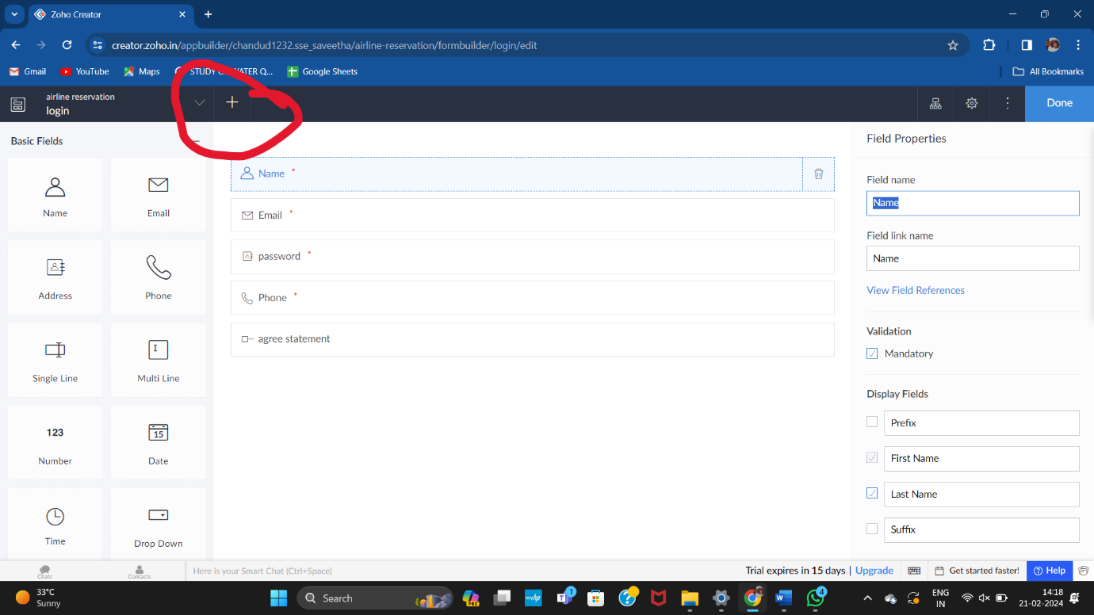

**STEP 7:DO SIMILARY UP TO 4 OR 5 FORM AND SELECT THE REQUIRED PROPERTIES FOR FORM.**

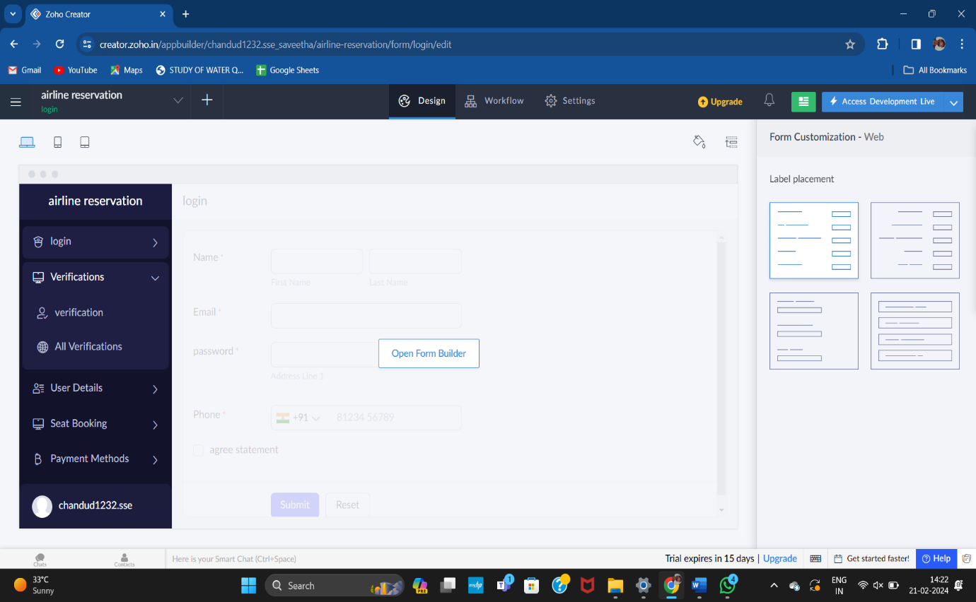

**STEP 8: NOW SELECT ACCESS DEVELOPMENT CHECK TO CHECK THE DESIGN “WE CAN CHECK IN 3 DIFFERENT FROMATS LIKE”IN WINDOWS, PHONE, TAB”.**

